Assignment -3

|  |  |
| --- | --- |
| Date | 11 October |
| Student Roll Number | 952819106029 |
| Team ID | PNT2022TMID50619 |
| Project Name | Project- Personal Expense Tracker |
| Maximum Mark | 2 Mark |

Question

1. Create a Bucket in IBM object storage.
2. Upload 5 images to IBM object storage and make it public. write html code to displaying all the 5 images. 3.Upload a CSS page to the object storage and use the same page in your HTML code.
3. Design a chatbot using IBM Watson assistant for hospital. Ex: User comes with query to know the branches for that hospital in your city. Submit the web URL of that chat bot as an assignment.
4. Create Watson assistant service with 10 steps and use 3 conditions in it. Load that script in HTML page.

# IBM Object Storage:

**Watson Assistant:**

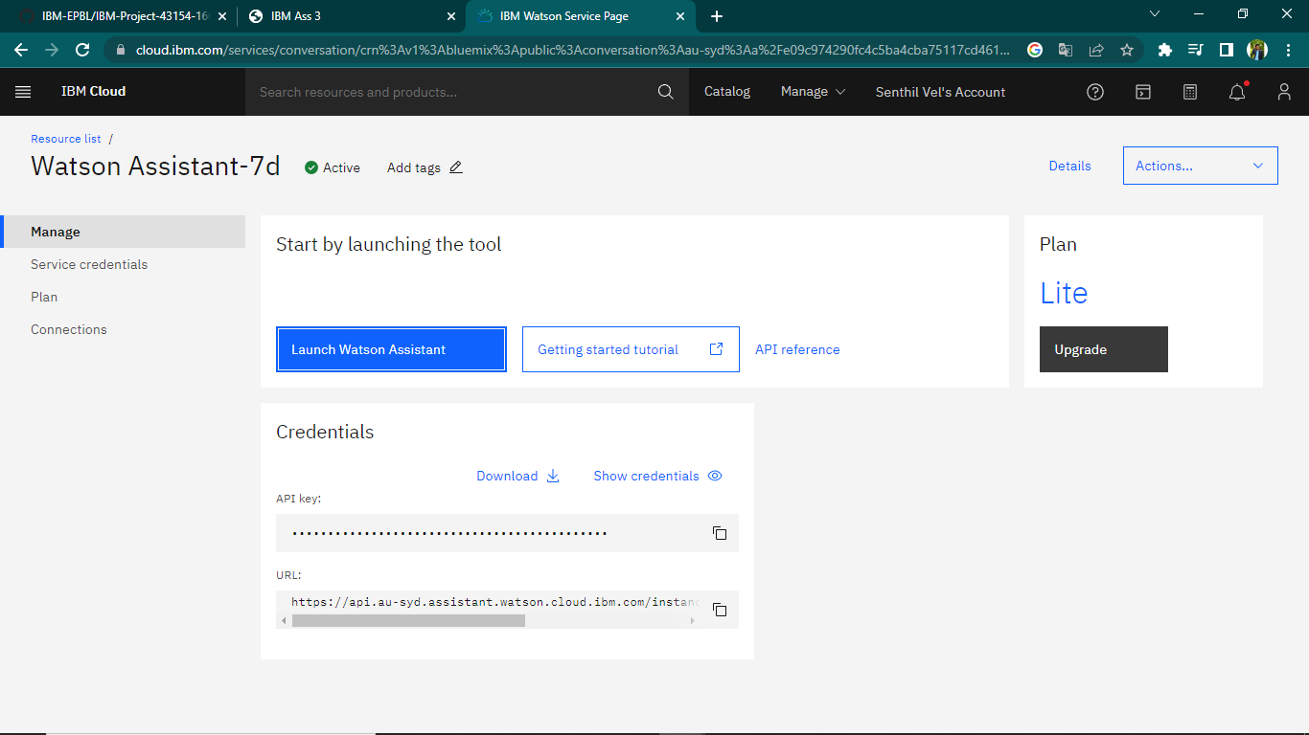

**HTML Code:**

<!DOCTYPE html>

<head>

  <meta charset="UTF-8">

  <meta http-equiv="X-UA-Compatible" content="IE=edge">

  <meta name="viewport" content="width=device-width, initial-scale=1.0">

  <title> IBM Ass 3</title>

  <link rel="stylesheet" href="https://senthillvel.s3.au-syd.cloud-object-storage.appdomain.cloud/assert/assignment3.css">

</head>

  <body class="size">

<div class="wrapper" style="background-color: rgba(0, 0, 0, 0.205) ;">

<h1>IBM ASSIGNMENT 3</h1>

<p><centre>SENTHIL VEL</centre></p>

<div class="img-area">

  <img class="activator " src="https://senthillvel.s3.au-syd.cloud-object-storage.appdomain.cloud/img/Hopetoun_falls.jpg">

  <img class="activator " src="https://senthillvel.s3.au-syd.cloud-object-storage.appdomain.cloud/img/beautiful-rain-forest-ang-ka-nature-trail-doi-inthanon-national-park-thailand-36703721.jpg">

  <img class="activator " src="https://senthillvel.s3.au-syd.cloud-object-storage.appdomain.cloud/img/beautiful-scenery-road-forest-with-lot-colorful-autumn-trees_181624-30942.jpg">

  <img class="activator " src="https://senthillvel.s3.au-syd.cloud-object-storage.appdomain.cloud/img/download.jpg">

</div>

  <script>

    window.watsonAssistantChatOptions = {

      integrationID: "f289a2fe-4c25-42fa-a5be-e69bbef93e4d", // The ID of this integration.

      region: "au-syd", // The region your integration is hosted in.

      serviceInstanceID: "227cbcd8-4d89-4c36-8622-8c827f1d474a", // The ID of your service instance.

      onLoad: function(instance) { instance.render(); }

    };

    setTimeout(function(){

      const t=document.createElement('script');

      t.src="https://web-chat.global.assistant.watson.appdomain.cloud/versions/" + (window.watsonAssistantChatOptions.clientVersion || 'latest') + "/WatsonAssistantChatEntry.js";

      document.head.appendChild(t);

    });

  </script>

</body>

</html>

# Output:

